**CSE 537 Assignment 5**

Atul Jha 110350053

atjha@cs.stonybrook.edu

Gerrard Lukacs 108166646

gerrard.lukacs@stonybrook.edu

**Naïve Bayes**

Sobel detector was used to calculate derivative in x and y direction.

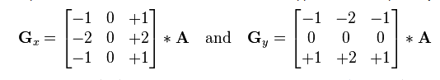

Using this the gradient direction was calculated as atan2 (Gy/Gx). Finally one of the 8 feature values (0, 1, 2, 3, 4, 5, 6 and 7) was assigned to a given pixel depending on which range the gradient lied.

0 -> 0 < gradient <= pi/4

1 -> pi/4 < gradient <= 3*pi/4

2 -> 3*pi/4 < gradient <= pi/2

3 -> pi/2 < gradient <= pi

4 -> -pi < gradient <= -3*pi/4

5 -> -3*pi/4 < gradient <= -pi/2

6 -> -pi/2 < gradient <= -pi/4

7 -> -pi/4 < gradient <= 0

Smoothing value of 0.0001 was used.

For the given test data set, the results were:

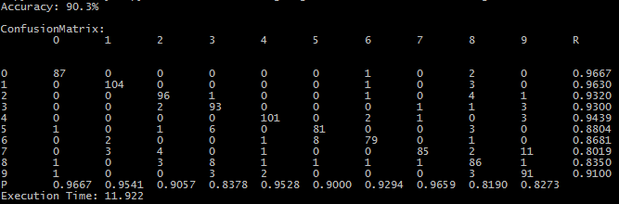

For the test data shared on piazza, the results were:

